# Use appropriate data types and write the SQL statements to create the tables defined in the schema above.

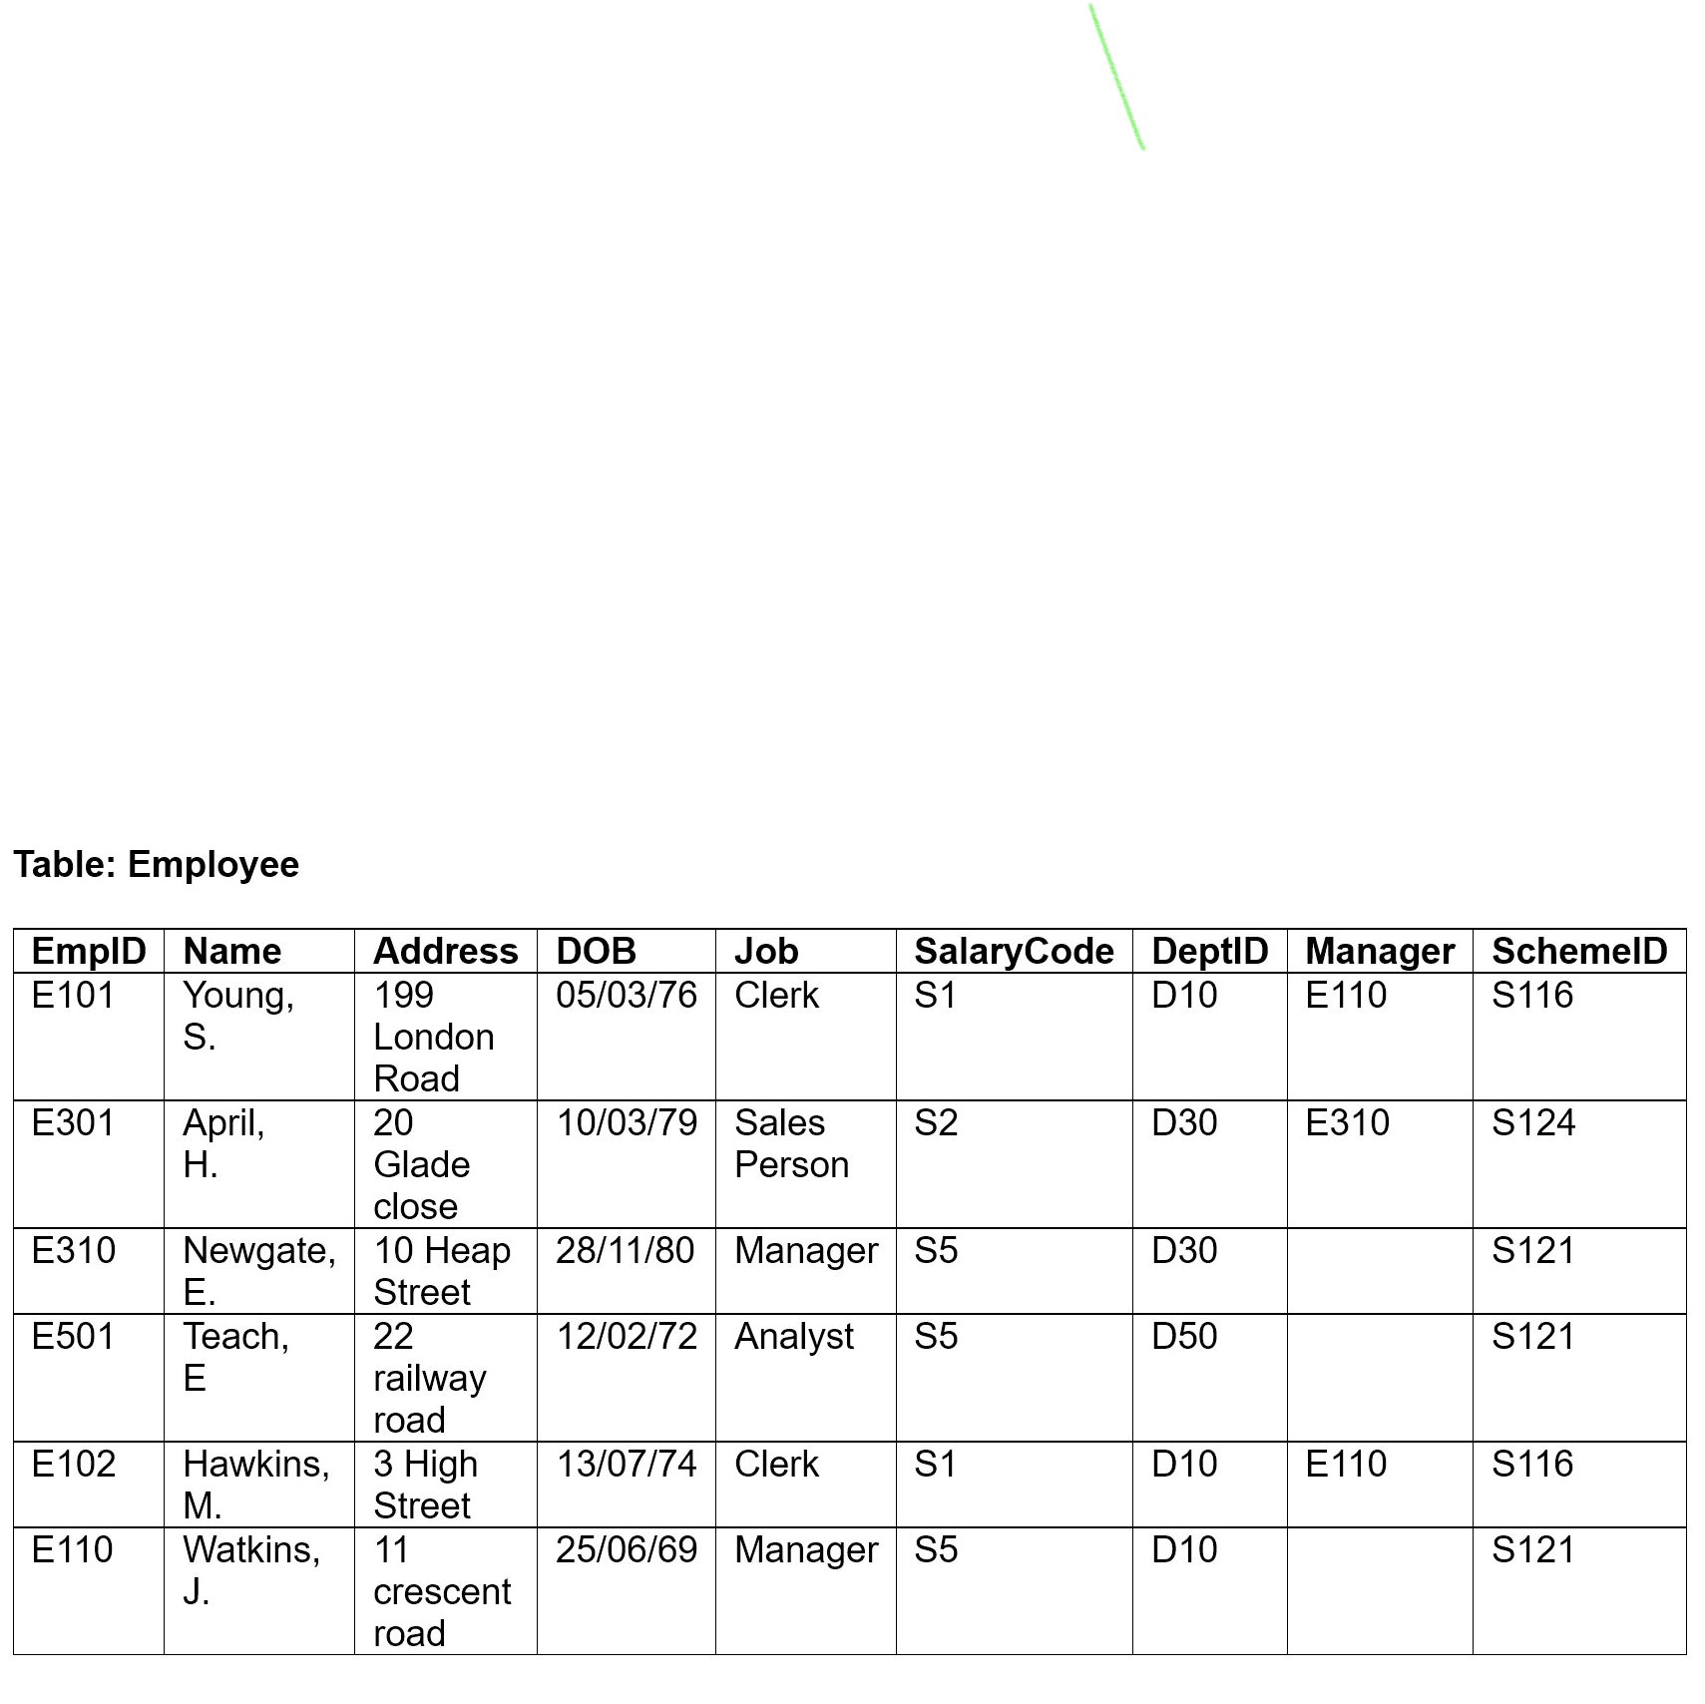

The above table could be created in SQL with the use of CREATE TABLE query. The table however, has relational dependencies with other tables. Attributes such as SalaryCode, DeptID, SchemeID are all parts of other tables. So, in order to create the Employee table, other related tables were created first.

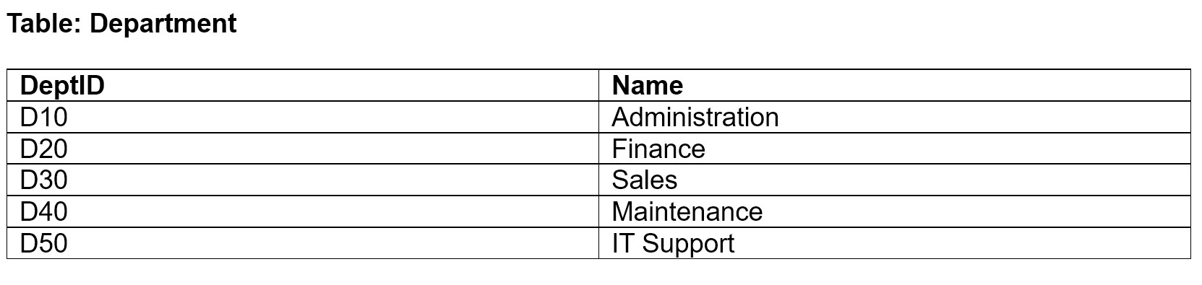

The **Department** table was created using the query given below:

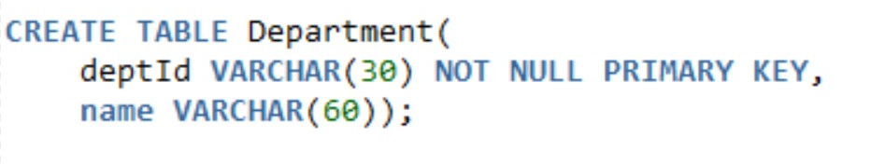

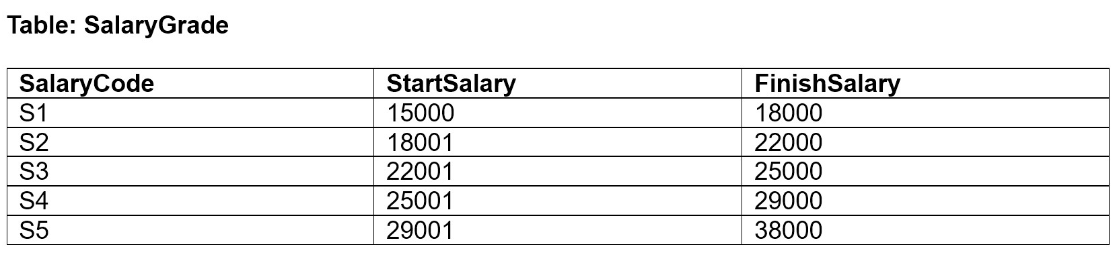

The **Salary** table was created using the following query:

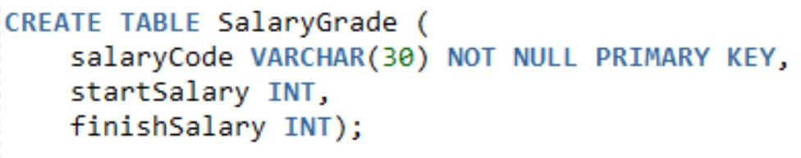

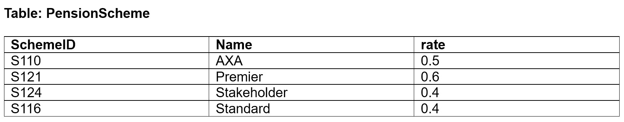

The following query was used to create the **Pension Scheme** table:

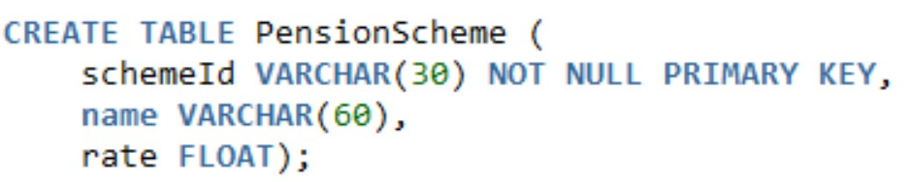

To finally create the **Employee** table, the following query was run.

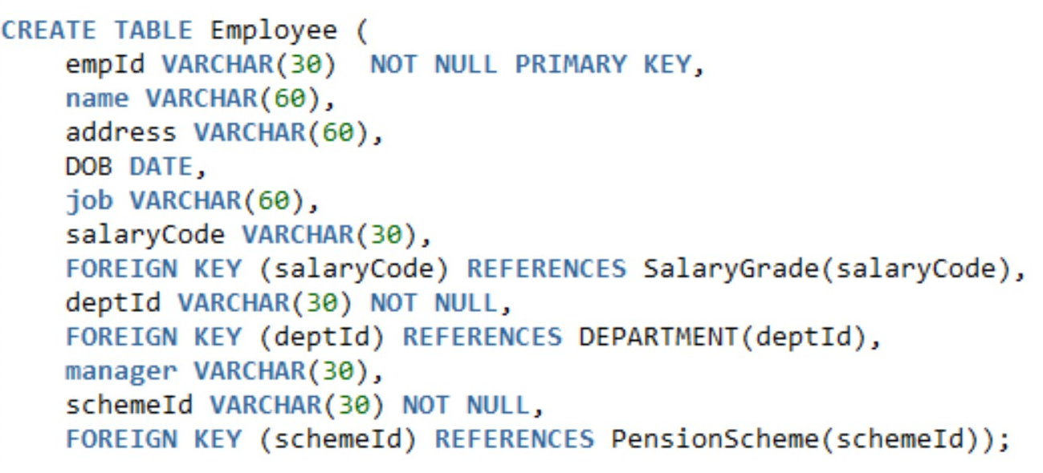

The CREATE TABLE queries showed the following output.

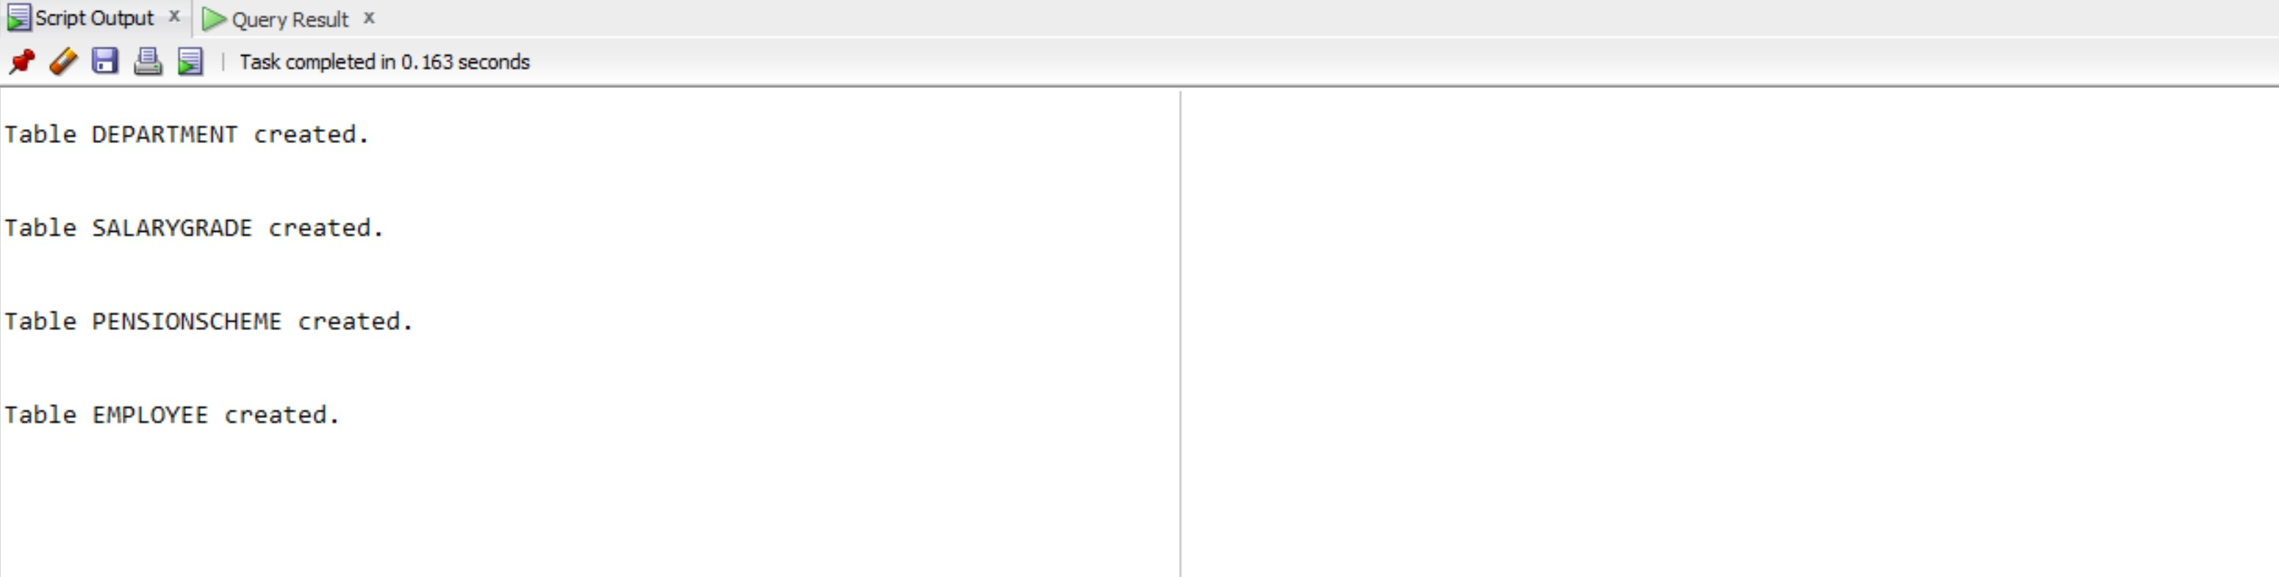

Figure 1 CREATE TABLE operation Script Output

The Employee table has the foreign key reference to Department, SalaryGrade and PensionScheme tables. These tables didn’t have any data inserted into them. The following SQL queries were used to populate the tables with the provided data.

1. Inserting into Department table

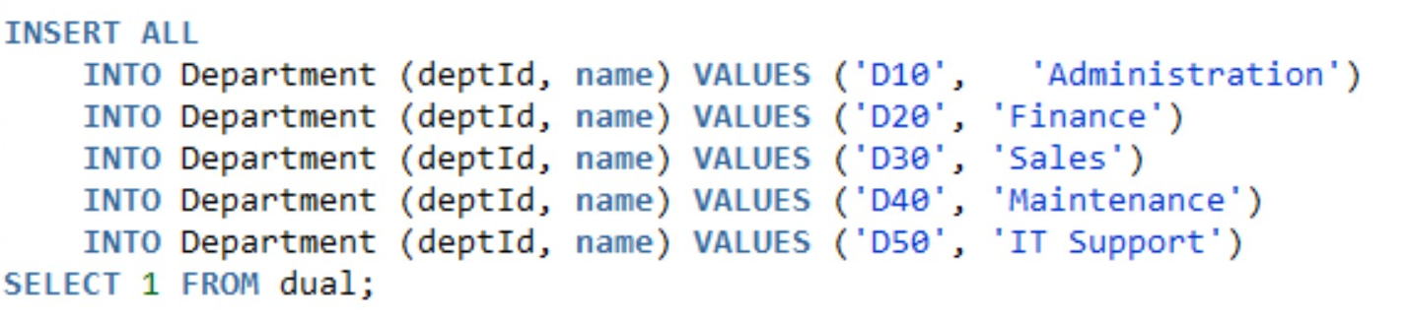

1. Inserting into SalaryGrade table

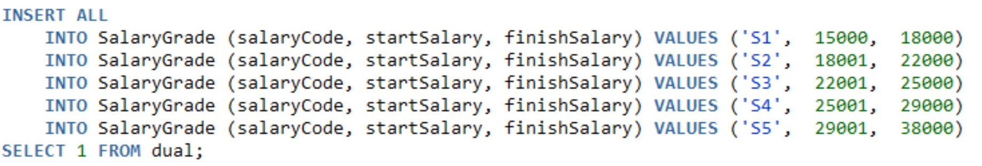

1. Inserting into PensionScheme table

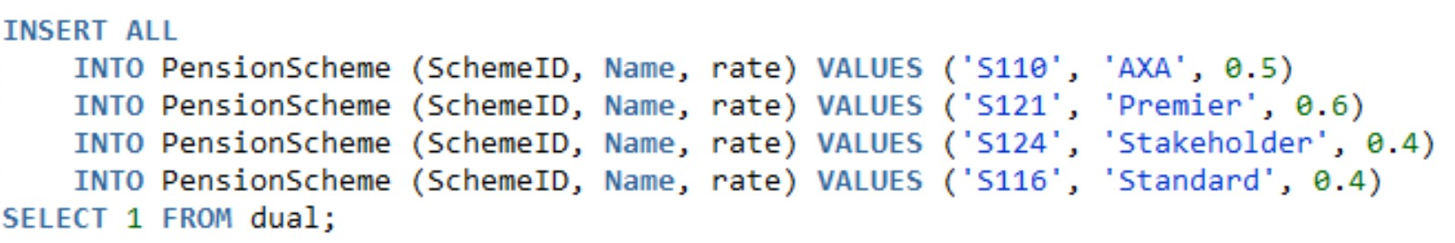

1. Inserting into Employee table

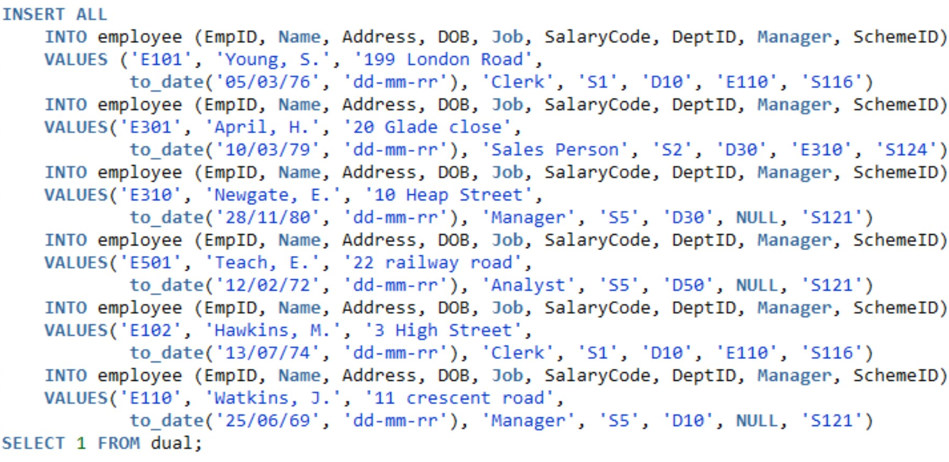

Performing all the INSERT operations provided the following Script output,

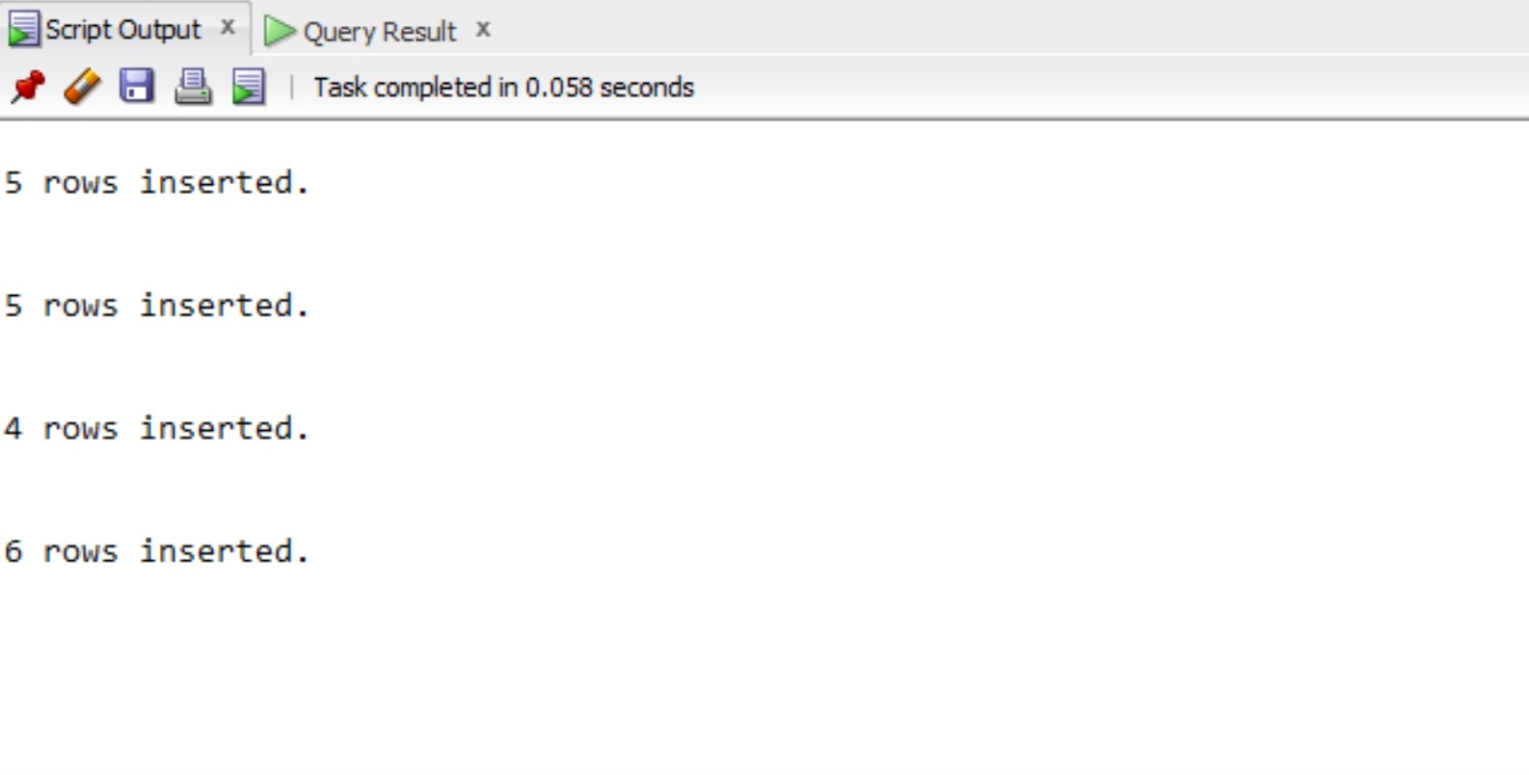

Figure 2 INSERT operation Script Output

# 2. Write SQL Statements to return the following data from the Employee database:

1. The name (in ascending order), the starting salary and department id of each employee within a descending order of department ids.

* Query:

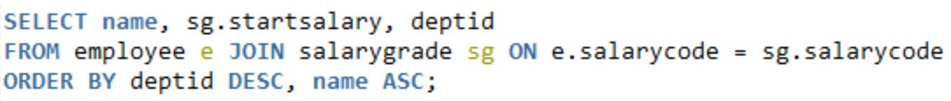

Output:

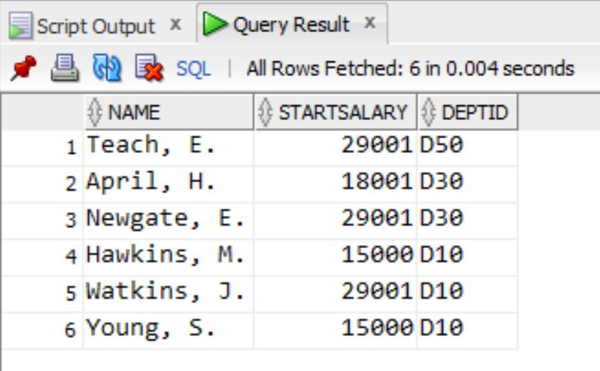

1. Give the number of employees for each of the pension schemes offered by the company. Result listing should include the name of each scheme and its corresponding number of employees who join the scheme.

* Query:



Output:

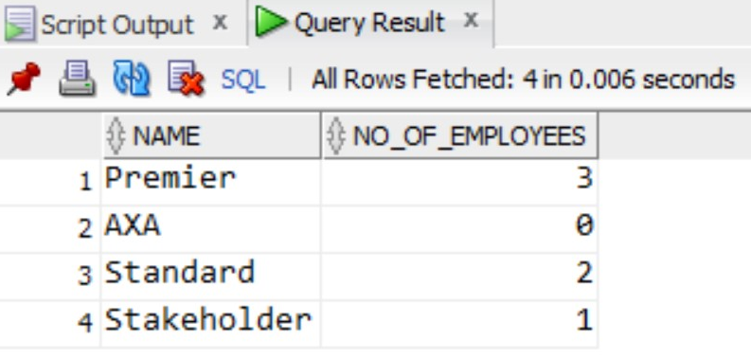

1. Give the total number of employees who are not managers but currently receive an annual salary of over £35,000.

* It is not possible to find the employees who receive an annual salary of over £35,000 since only a salary range instead of a particular value for the current salary of the employees has been provided.

However, with regard to the provided data, it is only possible for employees who have a salarygrade of S5 to receive an annual salary of over £35,000. In that case, the following query works.



The output of the query is:

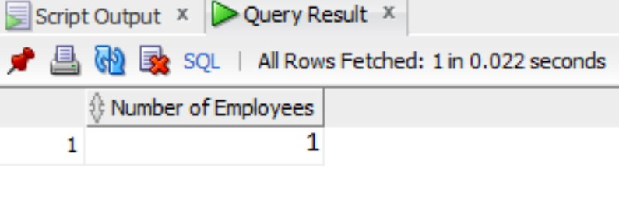

Alternatively, adding a column to the Employee table as ‘Current_salary’ might help in overcoming the problem. The employee table can be altered and a ‘Current_salary’ attribute can be added to it with the help of the following query.

ALTER TABLE employee

ADD Current_Salary INT;

With the assumption that an attribute ‘Current_salary’ has been added to the Employee table and some values for it are inserted and present, the query below would produce the desired result.

SELECT COUNT(empid) "Number of Employees"

FROM employee

WHERE job != 'Manager' AND current_salary > 35000;

1. List the id and name of each employee along with his/her manager’s name.

* Query:



The above query provides the following output:

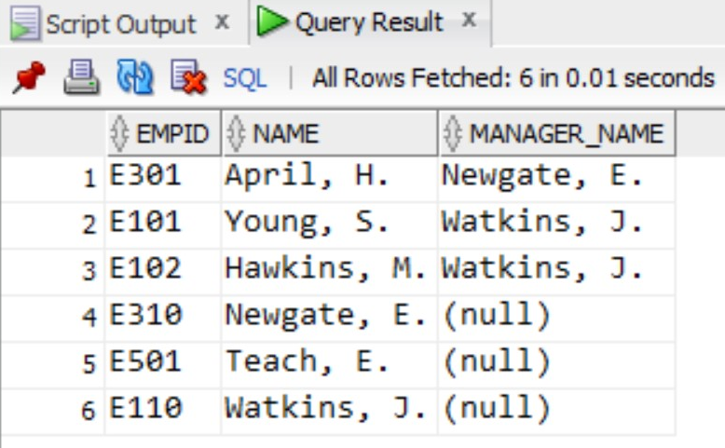

In case (null) values is not preferrred in the output, the function NVL can be used as,



The query returns a list of employees with their id and name substituting null with ‘No Manager’ in case the employee has not manager.

